Initial Project Code Structure
The project scope includes the development of a web-based food delivery management system using Python and Django integrated with CI/CD automation tools.
The project will include:
- Backend development using Django
- Frontend development using HTML, CSS, and JavaScript
- MySQL database integration
- Machine learning delivery prediction module
- GitHub Actions CI/CD automation
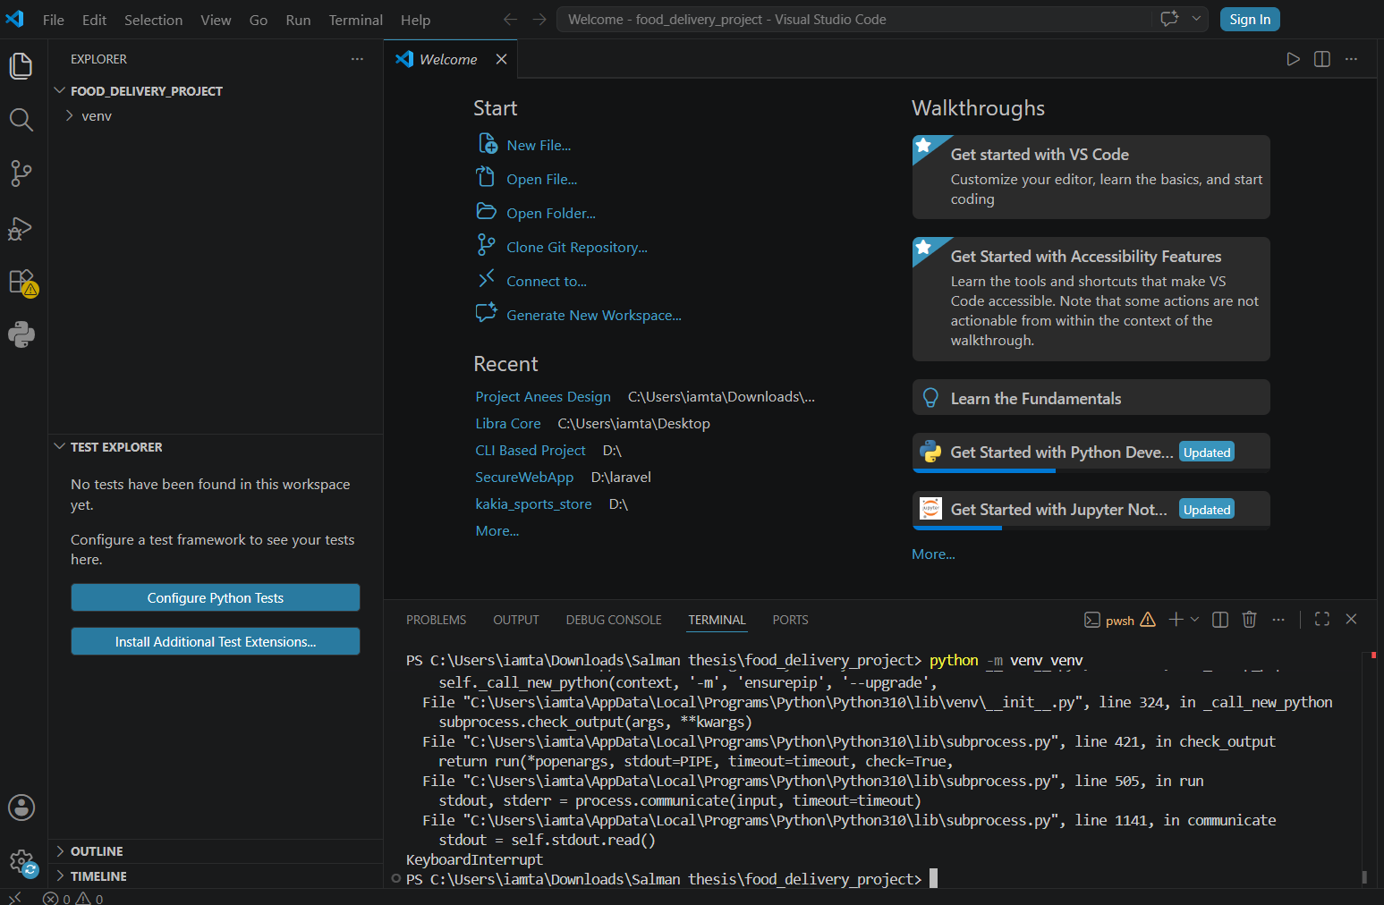
Figure 1: Create Virtual Environment
The development process began with creating a dedicated project directory and setting up a Python virtual environment to ensure isolated dependency management. After activating the environment, all required libraries such as Django, MySQL client, and machine learning packages were installed to support both web development and data-driven functionThen the next step is installing the necessary libraries;
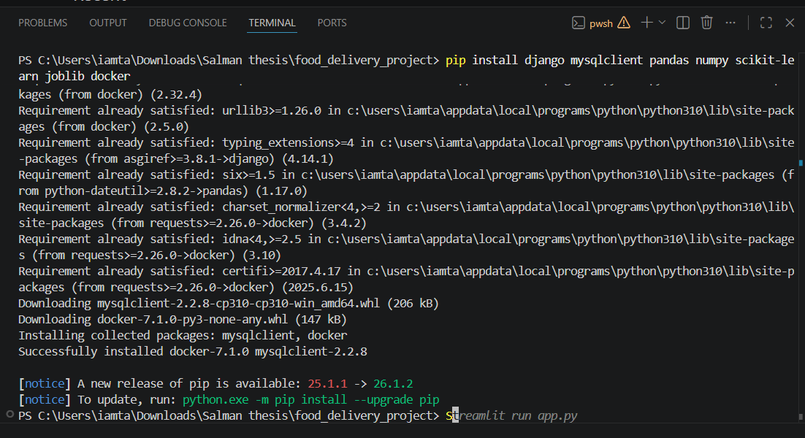
Figure 2: Installation of Libraries
Creating Django Project and running the server;
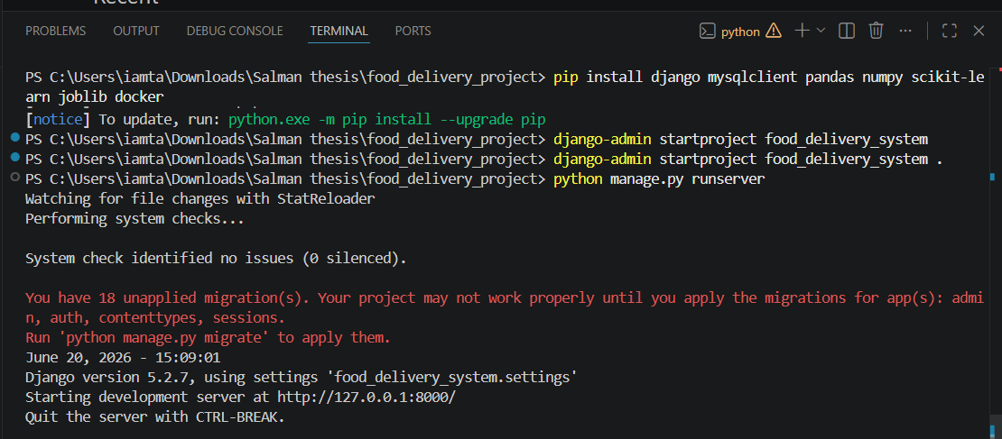
Figure 3: Run Django Server
Following this, a Django project named food_delivery_system was initialized, and the development server was executed successfully to confirm that the framework was correctly installed and functioning. This step ensured that the core backend environment was ready for further module development. The system was then structured to support multiple applications, laying the groundwork for scalable development in later stages.

Creating virtual environment
The environment is created and then activated, and the necessary libraries has been installed.
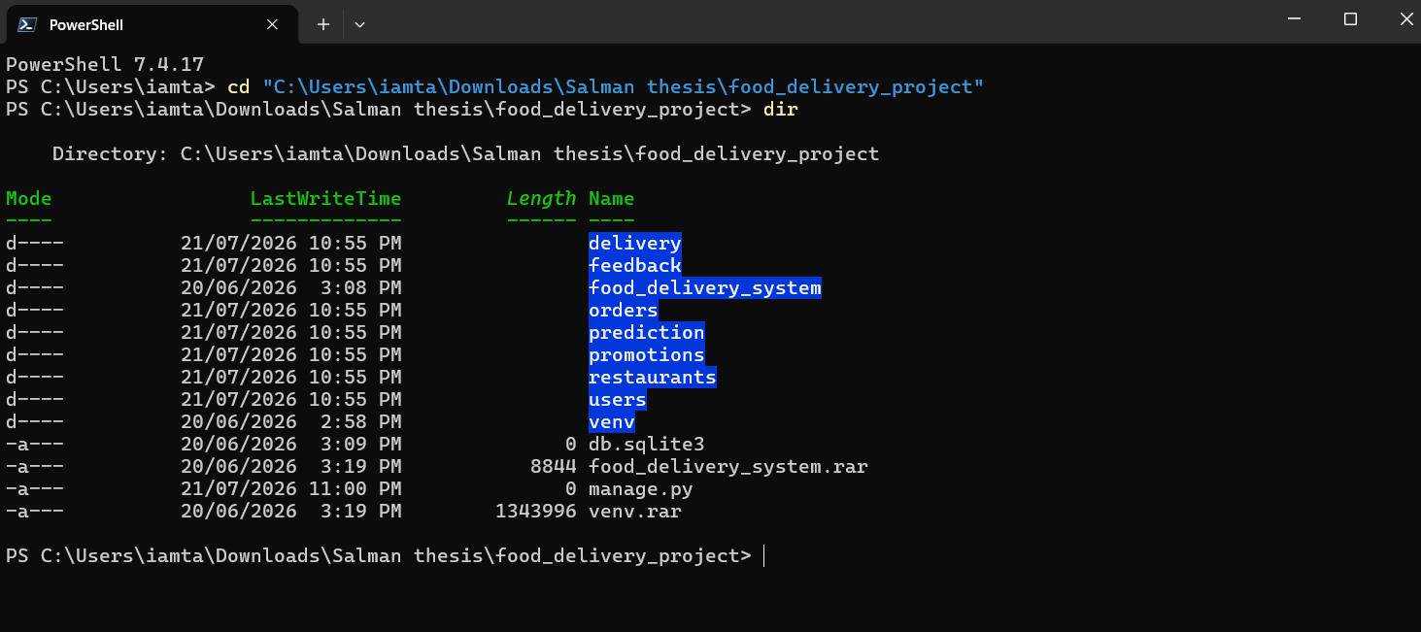
Install Django and required libraries
And here after activating the venv, the notepad is created.
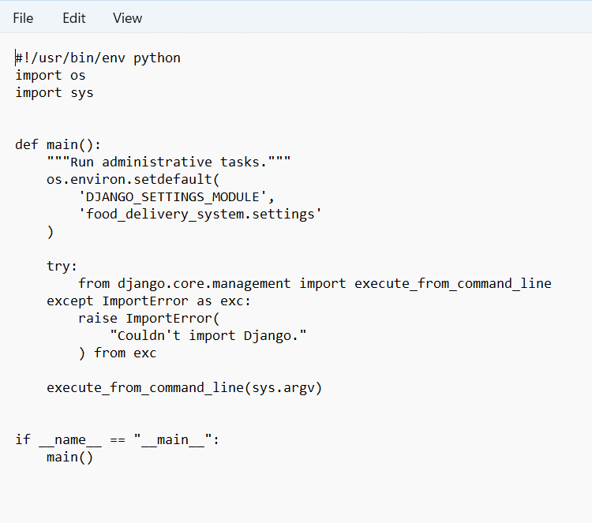
So, Virtual environment fixed Django installed, Project structure ready, Apps created, Server running, Ready for MySQL configuration and models.
Here I have created the database structure for:
- Users
- Restaurants
- Menu Items
- Orders
- Drivers
- Deliveries
- Feedback
- Promotions
- Delivery Predictions
Now all the models are created;
Django will detect the new models and create migration files.
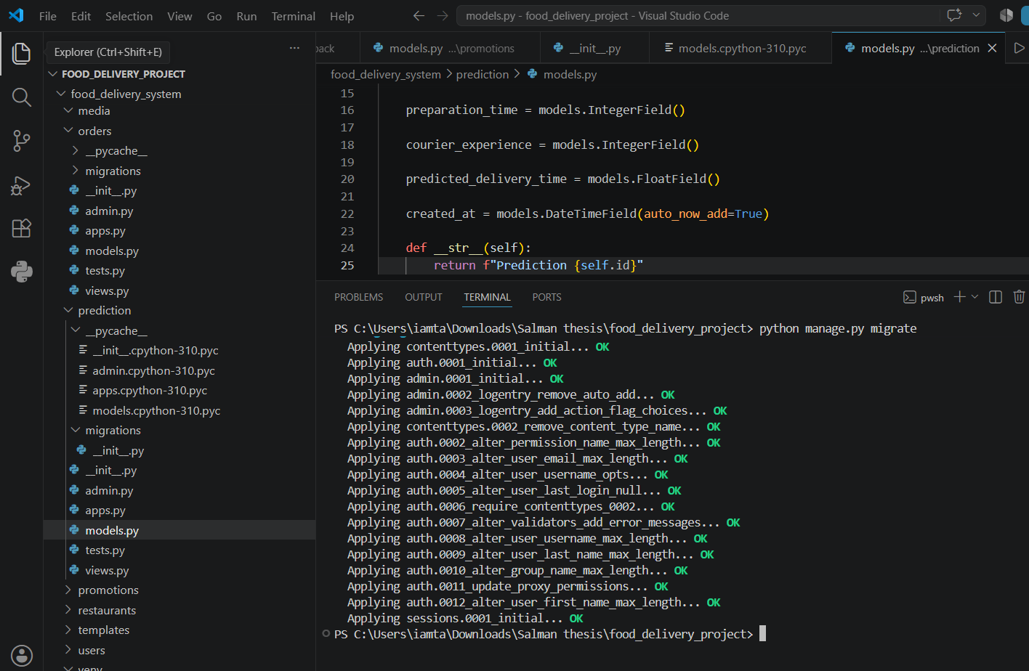

Now I will Configure Django Admin;

